**LAB MANUAL**

**NAME: MAHBOOB ALI**

**ROLL NO: BIT-24S-027**

**Lab no 07**

* **Task 1: Function to return the product of two numbers.**

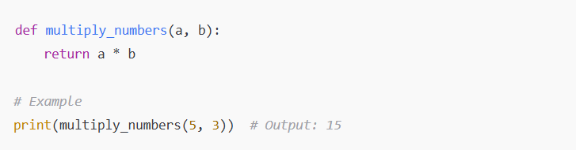

**Output:**

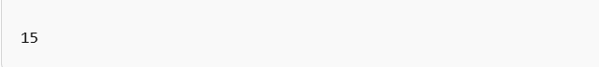

* **Task 2: Function to check if a number is even or odd.**

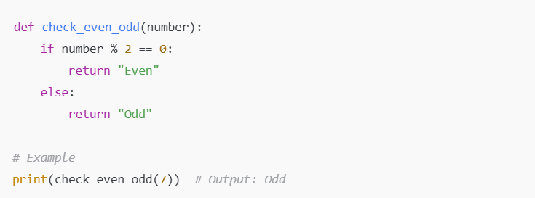

**Output:**

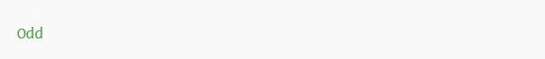

* **Task 3: Function to greet the user with name and age**

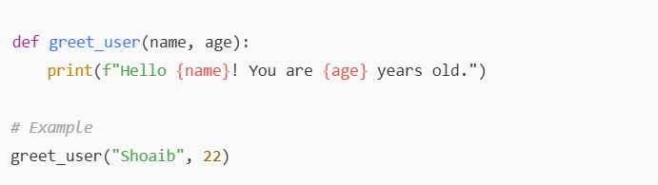

**Output:**

